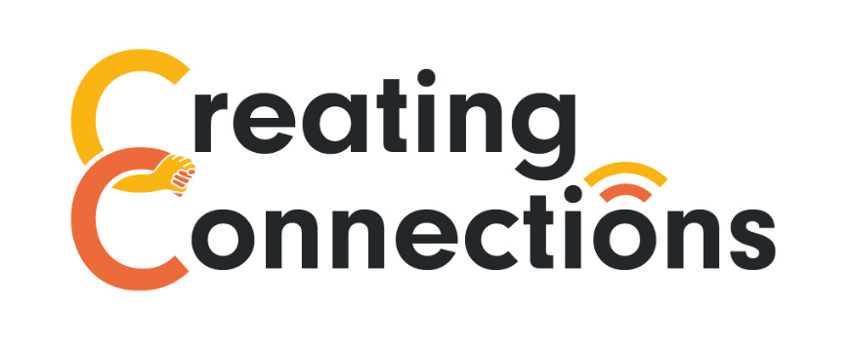

Creating Connections Volunteer Role Description
Creating Connections is a 6 month project, run by SeeAbility and Learning Disability England, aimed at supporting adults with learning disabilities to connect online.
We’re working with 24 partner groups, most of them member led, who are all committed to tackling loneliness and isolation among adults with learning disabilities during the Covid-19 pandemic and beyond.
We’re looking for people with a learning disability to act as peer supporters, as well as volunteers from the wider community, to increase social connections and reduce isolation for people with a learning disability.

What you will do

- Volunteers with lived experience might act as peer mentors, or contribute to and help shape peer mentoring programmes

- All volunteers: Sharing skills and experience with adults with learning disabilities, for example by helping to train people on topics including:

Staying safe online
Sending and receiving emails
Using social media
Hosting Zoom meetings

- Supporting partner groups with online social activities, for example quizzes and game nights, online classes and webinars and arts projects

When/how can I volunteer?

- You will work remotely from home, with the potential to offer safe, socially distanced support in the local community if possible

- You can work flexibly at hours to suit you

- It would be great if you could commit to volunteering until the project finishes in March, and there may be scope for continuing after this if you’d like to

- We will try to match you with the group(s) that best reflects your interests

Training

Before volunteering within this role you’ll need to complete some training, which at the moment is all online. Topics covered include:

- Safeguarding

- Data Protection

- Positive Behaviour Support

- Train the Trainer

We are committed to safeguarding and promoting the welfare of everyone we work with and in most cases you will be asked to complete an Enhanced DBS (or in Scotland a PVG) check for this role.

